1. What are ‘Assertions’ and ‘Triggers’ in SQL? Why do you need them? Explain with examples.

Assertions refer to semantic constraints and are meant to specify constraints that fall outside the scope of built-in relational model constraints. Assertions are useful so a user can ensure certain conditions will always be met or that some conditions cannot be violated in the database.

-specify queries that violate the desired outcome!

-Use a “NOT EXISTS” clause outside of query specifies the results of this query must be empty so that the condition will always be true  
EXAMPLE: an assertion created to make sure that the employee salary is not greater than their manager's salary

Triggers also refer to semantic constraints. They are stored procedures that are automatically executed when certain conditions are met. They monitor the database and have three important characteristics:

1. An event: usually database update operations (insert, delete, modify).
2. Condition: determines whether the action should be executed or not. If it is unspecified, action will be executed as soon as the event occurs, otherwise, it will be evaluated as true or false and executed when it is true.
3. Action: sequence of SQL statements that are executed.

(10 points)

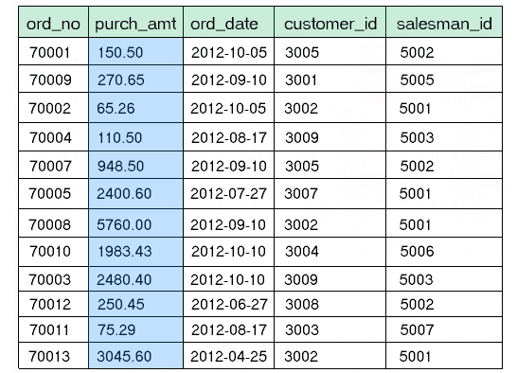(2) Consider the following **Orders** table. Write **one SQL query** that will compute the following from this table: (i) total number of orders, (ii) average purchase amount, (iii) maximum purchase amount, (iv) minimum purchase amount, and (v) total number of customers with purchase amounts greater than $1000.

1. SELECT COUNT(*)

FROM Orders;

1. SELECT AVG(purch_amt)

FROM Orders;

1. SELECT MAX(purch_amt)

FROM Orders;

1. SELECT MIN(purch_amt)

FROM Orders;

SELECT COUNT(customer_id)

FROM Orders

WHERE purch_amt > 1000;

(3)

(a) List the **four** informal design guidelines for relational databases.

1. Make semantics of relational attributes clear: create relations schema so it is easy to explain/understand its real-world meaning.

2. Reduce redundant information in tuples

3. Reduce NULL values in tuples: do

4. Disallow the possibility of creating spurious tuples

(b) Discuss the problem of spurious tuples and how you would prevent them.

Spurious tuples may be created when you create a relation schema that their matching attributes are not primary or foreign keys. This way, when performing join operations on relations, it will also output extra tuples that may not be required. We can prevent that from happening by creating relations that could be joined by matching attributes that are primary or foreign keys.

(10 points)

(4) Consider the following two relations in a database:

CUSTOMERS:

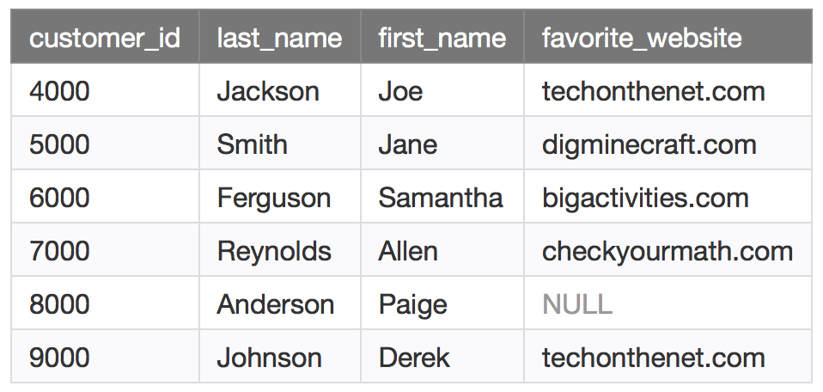

ORDERS:

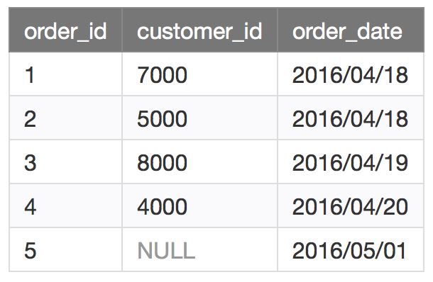

What are the **data output** generated for the following SQL retrieval commands?

(a) SELECT customers.customer_id, orders.order_id, orders.order_date

FROM customers INNER JOIN orders

ON customers.customer_id = orders.customer_id

ORDER BY customers.customer_id;

customer_id order_id order_date

4000 4 2016/04/20

5000 2 2016/04/18

7000 1 2016/04/18

8000 3 2016/04/19

(b) SELECT customers.customer_id, orders.order_id, orders.order_date

FROM customers LEFT OUTER JOIN orders

ON customers.customer_id = orders.customer_id

ORDER BY customers.customer_id;

customer_id

(c) SELECT customers.customer_id, orders.order_id, orders.order_date

FROM customers FULL OUTER JOIN orders

ON customers.customer_id = orders.customer_id

ORDER BY customers.customer_id;

(5 points)

(5) Consider the ER diagram shown below, which shows a simplified schema for an airline reservations system. Extract from the ER diagram **the requirements (Entities, attributes, relationships, keys) and constraints** that produced this schema. Be as precise as possible in your requirements and constraints specification.

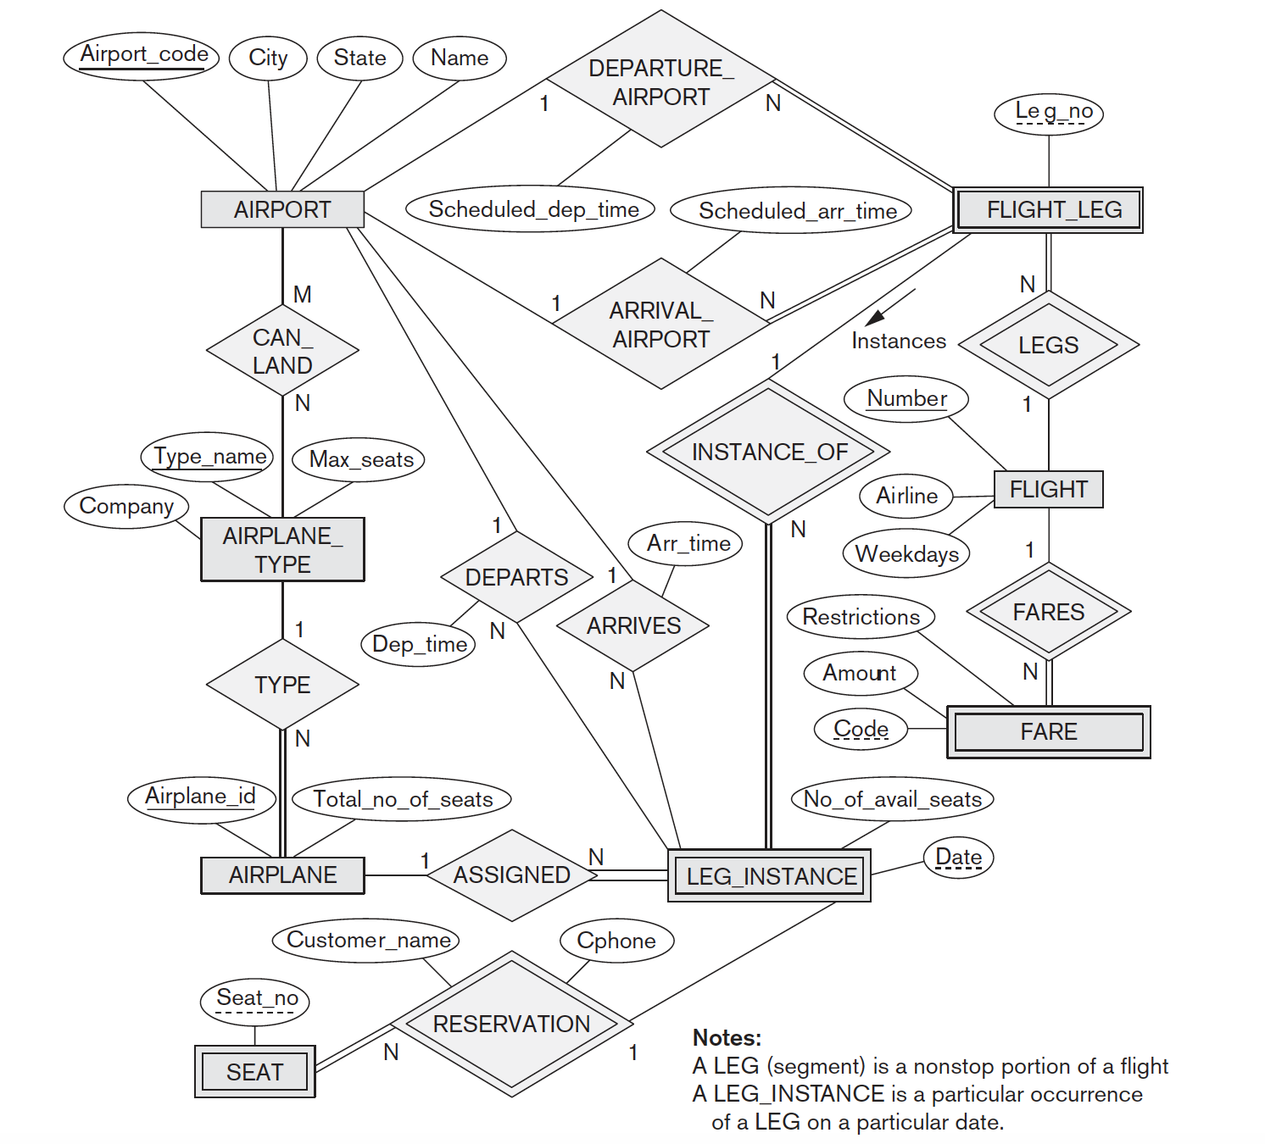

(20 points)

(6) What are the 2 properties we need to keep in mind while doing decompositions to achieve a highest normal form for a given relation schema? Which one is more critical and why? Explain.

1.

2.

(10 points)

(7) Consider the following relation for published books:

**BOOK (Book_title, Author_name, Book_type, List_price, Author_affiliation, Publisher)**

Following functional dependencies exist:

**Book_title à Publisher, Book_type**

**Book_type à List_price**

**Author_name à Author_affiliation**

What **normal form** is this relation in? Justify your answer.

Apply normalization to decompose this relation further. Explain reasons for each decomposition. (**Hint:** you may need to do multiple decompositions to achieve the highest normal form.)

(8) You are the DBA at a Fortune 500 company in the ***financial sector***. What are the various aspects you would consider to ensure that your company’s databases are secure? Discuss all possible security challenges you may face, and explain how you would ensure that data are secure.

Aspects I would consider to ensure database is secure: account creation and user authentication when logging in the database, flow control, inference control, and transmission and storage of sensitive data.

(10 points)